Work report 9_july_2021

Today I have resumed the training part of pp yolo I trained upto 140 epochs the pretrained weights I have used was weights at 127 epochs.

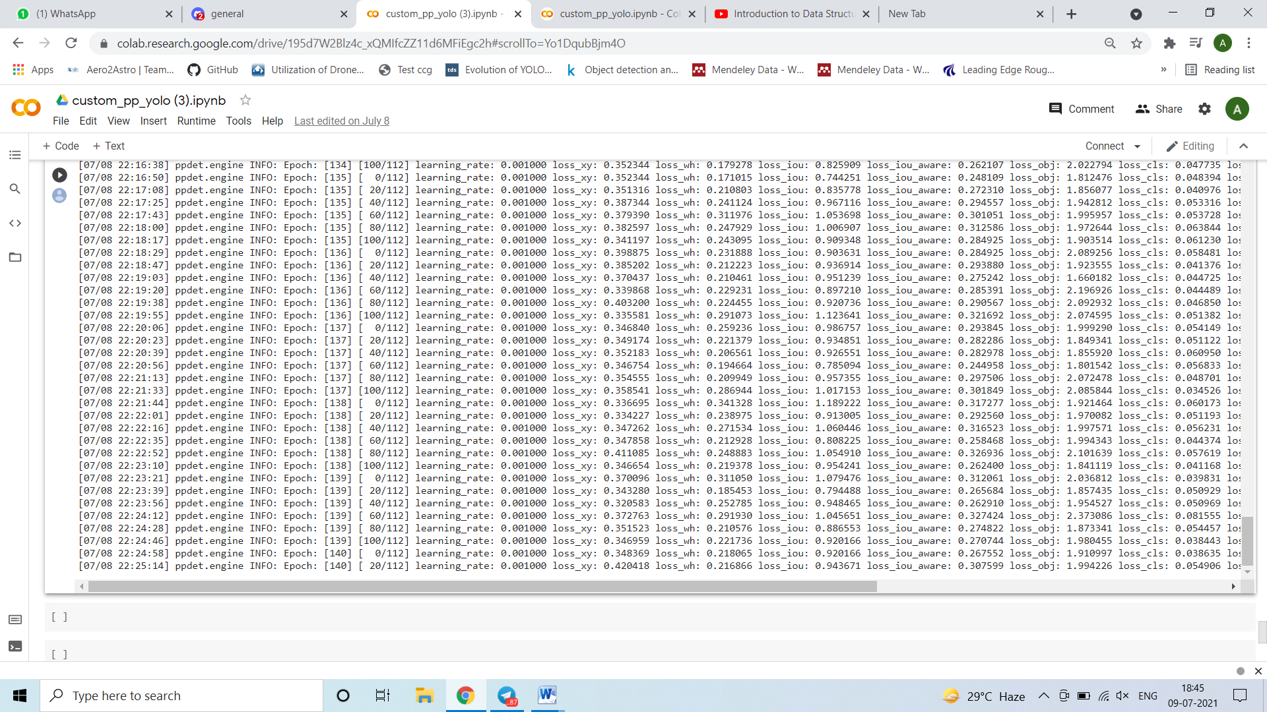

Loss is still around 3 to 4 and I have tried to detect the object from the weights of (127+127)Epochs it doesnot detect the objects yet.